HTML ASSIGNMENT:

1.

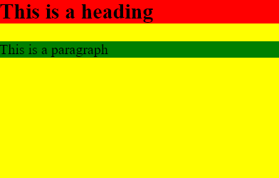

Code:

<!DOCTYPE html>

<html lang="en">

<head>

<meta charset="UTF-8">

<title>Document</title>

</head>

<body>

<section style="background-color: yellow; height:300px ;width: auto">

<h1 style="background-color: red">This is a heading</h1>

<p style="background-color: green">This is a paragraph</p>

</section><br>

</body>

</html>

2. A] with border

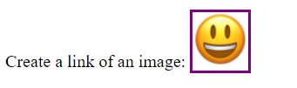

Code:

<!DOCTYPE html>

<html lang="en">

<head>

<meta charset="UTF-8">

<title>Document</title>

<style>

div a img {

width: 50px;

height: 50px;

}

</style>

</head>

<body>

<div>

<label for="img-1">Create a link of an image:</label>

<a id="img-1" href="https://www.google.com/search?q=smiling+face&rlz=1C1CHBF_enIN925IN925&oq=smiling&aqs=chrome.1.69i57j0i433i512l5j0i512l3j0i433i512.3584j0j7&sourceid=chrome&ie=UTF-8" style="border:3px solid purple; padding: 35px 0px 0px 0px;">

<img src="smiling%20face.jpg" alt='Smiling face' height:200px width:300px>

</a>

</div>

<br><br>

</body>

</html>

B] without border:

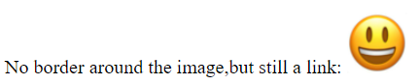

Code:

<!DOCTYPE html>

<html lang="en">

<head>

<meta charset="UTF-8">

<title>Document</title>

<style>

div a img {

width: 50px;

height: 50px;

}

</style>

</head>

<body>

<div>

<label for="img-2">No border around the image,but still a link:</label>

<a id="img-2" href="https://www.google.com/search?q=smiling+face&rlz=1C1CHBF_enIN925IN925&oq=smiling&aqs=chrome.1.69i57j0i433i512l5j0i512l3j0i433i512.3584j0j7&sourceid=chrome&ie=UTF-8" style="border:none;">

<img src="smiling%20face.jpg" alt='Smiling face'>

</a>

</div>

<br><br>

</body>

</html>

3.

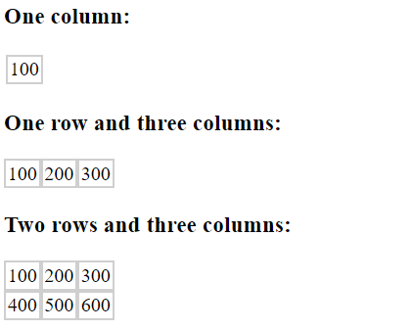

Code:

<!DOCTYPE html>

<html lang="en">

<head>

<meta charset="UTF-8">

<title>Document</title>

<style>

td {

border: 2px double #cfcfcf;

}

<style>

</head>

<body>

<section>

<h3>One column:</h3>

<table>

<tr>

<td>100</td>

</tr>

</table>

<h3>One row and three columns:</h3>

<table cellspacing=0>

<tr>

<td>100</td>

<td>200</td>

<td>300</td>

</tr>

</table>

<h3>Two rows and three columns:</h3>

<table cellspacing=0>

<tr>

<td>100</td>

<td>200</td>

<td>300</td>

</tr>

<tr>

<td>400</td>

<td>500</td>

<td>600</td>

</tr>

</table>

</section>

<br><br>

</body>

</html>

4.

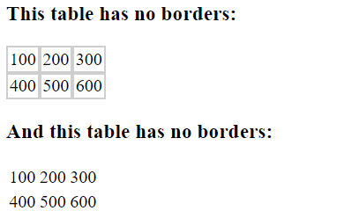

Code:

<!DOCTYPE html>

<html lang="en">

<head>

<meta charset="UTF-8">

<title>Document</title>

<style>

.nobro td {

border: none;

}

<style>

</head>

<body>

<div>

<h3>This table has no borders:</h3>

<table cellspacing=0>

<tr>

<td>100</td>

<td>200</td>

<td>300</td>

</tr>

<tr>

<td>400</td>

<td>500</td>

<td>600</td>

</tr>

</table>

<h3>And this table has no borders:</h3>

<table class="nobro">

<tr>

<td>100</td>

<td>200</td>

<td>300</td>

</tr>

<tr>

<td>400</td>

<td>500</td>

<td>600</td>

</tr>

</table>

</div>

<br><br>

</body>

</html>

5.

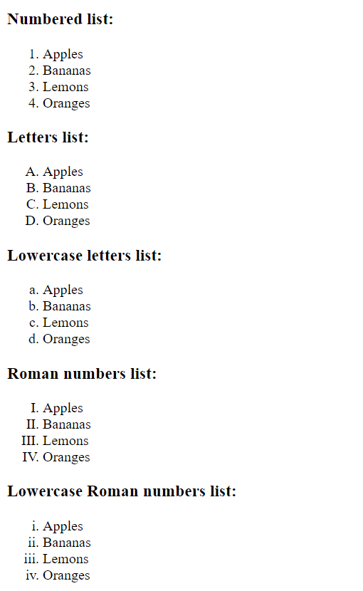

Code:

<!DOCTYPE html>

<html lang="en">

<head>

<meta charset="UTF-8">

<title>Document</title>

</head>

<body>

<div>

<h3>Numbered list:</h3>

<ol>

<li>Apples</li>

<li>Bananas</li>

<li>Lemons</li>

<li>Oranges</li>

</ol>

<h3>Letters list:</h3>

<ol type="A">

<li>Apples</li>

<li>Bananas</li>

<li>Lemons</li>

<li>Oranges</li>

</ol>

<h3>Lowercase letters list:</h3>

<ol type="a">

<li>Apples</li>

<li>Bananas</li>

<li>Lemons</li>

<li>Oranges</li>

</ol>

<h3>Roman numbers list:</h3>

<ol type="I">

<li>Apples</li>

<li>Bananas</li>

<li>Lemons</li>

<li>Oranges</li>

</ol>

<h3>Lowercase Roman numbers list:</h3>

<ol type="i">

<li>Apples</li>

<li>Bananas</li>

<li>Lemons</li>

<li>Oranges</li>

</ol>

</div><br><br>

</body>

</html>

6.

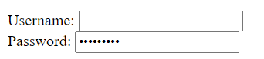

Code:

<!DOCTYPE html>

<html lang="en">

<head>

<meta charset="UTF-8">

<title>Document</title>

</head>

<body>

<div>

<label for="user">Username: </label>

<input type="text" id="user" name="user">

<br>

<label for="pass">Password:</label>

<input type="password" id="pass" name="pass">

</div>

<br><br>

</body>

</html>

7.



Code:

<!DOCTYPE html>

<html lang="en">

<head>

<meta charset="UTF-8">

<title>Document</title>

<style>

#submit{

border-color: aqua;

}

</style>

</head>

<body>

<div>

<form>

<input type="checkbox" id="box-1" name="box-1">

<label for="box-1">I have a bike</label>

<br>

<input type="checkbox" id="box-2" name="box-2">

<label for="box-2">I have a car</label>

<br><br>

<input id="submit" type="submit" value="Submit">

</form>

</div><br><br>

</body>

</html>

8.

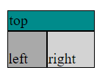

Code:

<!DOCTYPE html>

<html lang="en">

<head>

<meta charset="UTF-8">

<title>Document</title>

</head>

<body>

<div class="eightndnine">

<table cellspacing=0>

<tr>

<td colspan="2" style="background-color:darkcyan">top</td>

</tr>

<tr>

<td style="background-color: darkgray; ;padding: 20px 20px 0px 0px">left</td>

<td style="background-color: lightgray;padding:20px 20px 0px 0px">right</td>

</tr>

</table>

</div>

<br><br>

</body>

</html>

9.

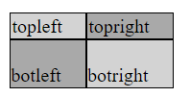

Code:

<!DOCTYPE html>

<html lang="en">

<head>

<meta charset="UTF-8">

<title>Document</title>

</head>

<body>

<div class="eightndnine">

<table cellspacing=0>

<tr>

<td style="background-color:lightgray">topleft</td>

<td style="background-color:darkgray">topright</td>

</tr>

<tr>

<td style="background-color: darkgray; ;padding: 20px 20px 0px 0px">botleft</td>

<td style="background-color: lightgray;padding:20px 20px 0px 0px">botright</td>

</tr>

</table>

</div>

</body> </html>